SYNOPSIS

Report on

Skill-Based Career Assessment and Domain Recommendation System

by
Sujal Gupta 2426mca189 Suhel Saifi 2426mca708 Zeeshan Malik 2426mca339 Syed Zaid Ashraf 2426mca712

Session:2024-2026 (IV Semester)

Under the supervision of

Dr. Neelam Rawat

Ms. Anita Yadav
KIET Group of Institutions, Delhi-NCR, Ghaziabad

Department Of Computer Applications
KIET GROUP OF INSTITUTIONS, DELHI-NCR,GHAZIABAD-201206

ABSTRACT

In the rapidly evolving digital era, students and beginners often face difficulty in identifying the most suitable career domain due to a lack of structured skill evaluation and proper career guidance. Many individuals choose technology domains based on trends or peer influence rather than an objective assessment of their abilities, which may lead to inefficient learning paths and career dissatisfaction. Therefore, an automated system that evaluates user skills and provides domain recommendations based on measurable performance is highly essential.
This project proposes a Skill-Based Career Assessment and Domain Recommendation System, a web-based platform designed to analyze users’ technical skills, interests, and analytical abilities through an interactive assessment process. The system allows users to register and provide academic and skill-related information, followed by a dynamically generated Multiple Choice Question (MCQ) assessment covering aptitude, logical reasoning, programming fundamentals, database concepts, and user interface understanding.
The system utilizes a rule-based evaluation mechanism that combines weighted scoring and domain-mapping techniques to analyze user responses. Based on performance analysis, the platform calculates domain suitability scores and recommends the most appropriate career path, particularly focusing on Full Stack Development.
After completion of the assessment, users receive a detailed analytical report highlighting their strengths, weaknesses, domain compatibility percentage, and personalized improvement suggestions. The application is developed using a full-stack architecture consisting of a React-based frontend, Node.js and Express backend for assessment processing, and MongoDB for secure data storage and management.

The primary aim of this project is to assist students and beginners in making informed career decisions through structured skill evaluation, thereby reducing uncertainty and promoting efficient learning and professional growth.

Keywords: Career Assessment, Domain Recommendation, Rule-Based System, Full Stack Development, Skill Evaluation, Web Application.
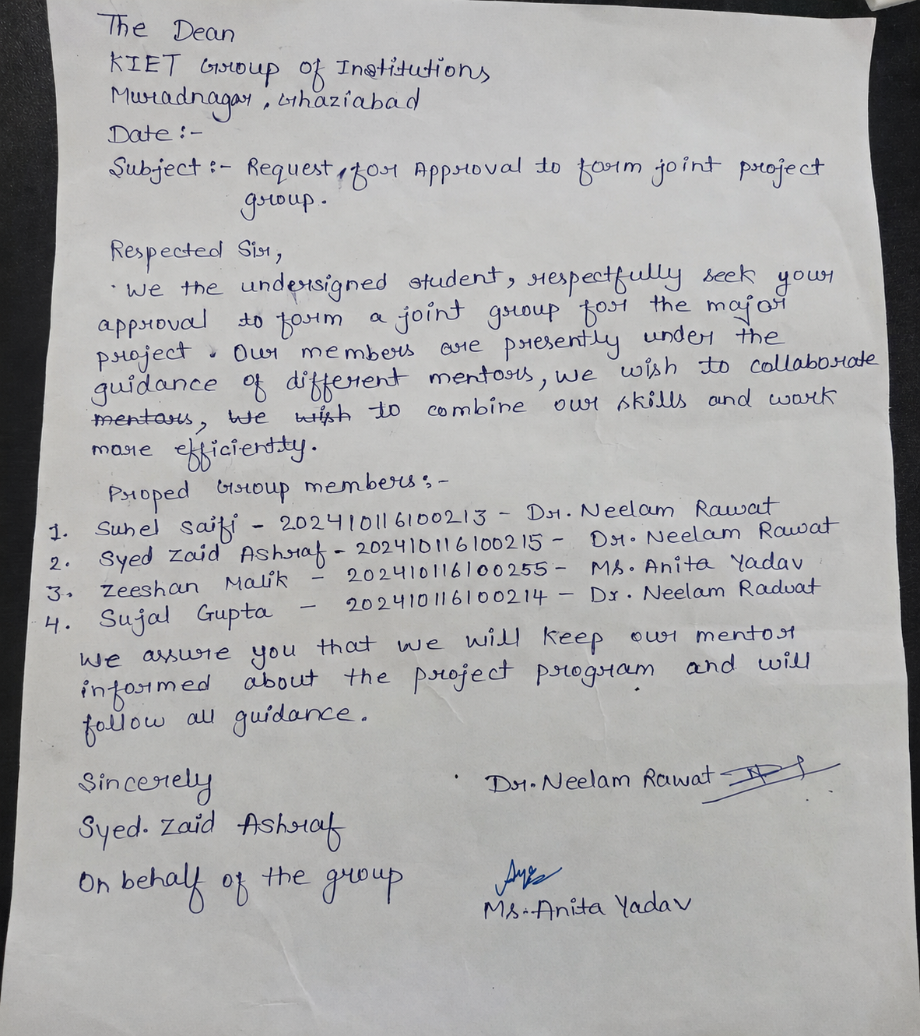

TABLE OF CONTENTS

Page Number
- Introduction 5
- Literature Review 6
- Project Objective 9
- Software Requirements 10
- Project Flow 12
- Project Outcome 14
- Proposed Time Duration 15
- References 16

Introduction

The rapid growth of the information technology industry has created numerous career opportunities across different technology domains such as web development, data analysis, software testing, and system design. However, students and fresh graduates often struggle to identify the most suitable career path due to limited awareness of their actual skill levels and domain requirements. Many learners select career domains based on trends, peer influence, or incomplete information rather than structured evaluation, which may result in inefficient skill development and reduced career satisfaction.

Traditional career guidance methods mainly rely on manual counseling or self-assessment, which may lack objectivity and measurable analysis. With the increasing availability of web technologies, automated assessment systems can provide a more reliable and scalable approach to evaluating user capabilities. A skill-based evaluation platform can analyze technical knowledge, logical reasoning ability, and problem-solving skills to generate meaningful career recommendations.

The proposed Skill-Based Career Assessment and Domain Recommendation System aims to address this problem by providing an interactive web-based platform that evaluates students through structured Multiple Choice Question (MCQ) assessments. The system collects user information such as academic background, technical skills, and interests, and dynamically generates assessment questions related to programming fundamentals, aptitude, database concepts, and user interface understanding.

Furthermore, the system provides a detailed analytical report highlighting strengths, weaknesses, and improvement suggestions, enabling students to make informed decisions about their learning journey. The application is implemented using modern full-stack technologies including React for the frontend interface, Node.js and Express for backend processing, and MongoDB for data management.

The overall objective of this project is to assist students and freshers in identifying suitable technology domains through structured skill evaluation, thereby supporting informed career planning and effective professional development.

Literature Review
Career guidance and recommendation systems have become an important research area due to the rapid growth of technology-driven careers and increasing confusion among students while selecting suitable professional domains. Various approaches and systems have been proposed to evaluate user skills and provide career recommendations. The following review highlights major developments related to the proposed system.

1. Online Career Assessment Platforms
Many existing career guidance platforms provide aptitude or personality-based assessments to recommend career paths. These systems mainly analyze user interests rather than technical capabilities, which limits their effectiveness for students pursuing technology-based careers. They often provide generalized suggestions without detailed performance analysis.

2. Questionnaire-Based Recommendation Systems
Traditional assessment systems use fixed questionnaires to evaluate users. Although easy to implement, these systems lack dynamic question generation and technical skill evaluation. As a result, recommendations may not accurately reflect a user’s actual abilities or domain readiness.

3. Machine Learning-Based Career Recommendation Systems
Some research studies propose machine learning models for predicting suitable career domains based on user data. While these approaches improve prediction accuracy, they require large datasets, complex training processes, and high computational resources. Additionally, the decision-making process is often difficult for users to understand.

4. Rule-Based Expert Systems
Rule-based systems use predefined logical rules and weighted scoring methods to evaluate user responses. These systems are transparent, interpretable, and easier to maintain compared to machine learning models. They allow users to understand how recommendations are generated, increasing system reliability and trust.

5. Gap in Existing Systems
Most existing solutions either focus only on aptitude testing or use complex AI models without transparency. There is a need for a system that combines technical skill assessment with explainable evaluation logic. The proposed project addresses this gap by implementing a rule-based domain recommendation system integrated within a full-stack web application.

6. Web-Based Assessment Applications Modern web technologies enable scalable assessment platforms accessible through browsers without specialized software installation. Full-stack architectures combining frontend frameworks and backend servers allow real-time assessment processing, result generation, and secure data storage. Web-based systems improve accessibility and user experience while supporting dynamic content generation and analytics visualization.

Performance Analytics and Reporting Systems Recent academic projects emphasize analytical reporting as an essential component of assessment systems. Instead of providing only final scores, modern platforms generate detailed feedback including strengths, weaknesses, and improvement suggestions. Analytical dashboards help users understand performance patterns and guide future learning decisions.

8. Identified Research Gap Existing systems either focus on personality-based recommendations, rely heavily on complex machine learning models, or lack transparency in decision-making. There is a need for a system that:

Evaluates technical skills objectively

Provides transparent and explainable recommendations

Generates detailed analytical reports

Is simple, scalable, and accessible through a web platform

The proposed Skill-Based Career Assessment and Domain Recommendation System addresses these limitations by integrating MCQ-based assessment, rule-based evaluation logic, weighted scoring mechanisms, and performance analytics within a full-stack web application.

Project Objective
The primary objective of the Skill-Based Career Assessment and Domain Recommendation System is to design and develop an intelligent web-based platform that evaluates students’ technical skills through a structured assessment process and recommends the most suitable career domain based on measurable performance analysis. The system aims to provide transparent, data-driven career guidance for students and freshers entering the technology industry.
The detailed objectives of the project are described below:
1. Development of an Interactive Web-Based Platform
To design and implement a user-friendly web application that allows students to register, log in, and access assessment features seamlessly. The platform aims to provide an intuitive interface that ensures ease of navigation and improves user engagement during the assessment process.
2. Collection and Management of User Profile Information
To gather essential user details such as academic background, technical skills, and areas of interest in order to personalize the assessment experience. The system will securely store user information and use it to generate relevant evaluations and reports.
3. Skill-Based Assessment Implementation
To develop an MCQ-based assessment module that evaluates users across multiple skill areas including aptitude, logical reasoning, programming fundamentals, database concepts, and user interface understanding. The objective is to measure practical knowledge rather than subjective preferences.
4. Design of Rule-Based Evaluation Engine
To implement a hybrid rule-based evaluation mechanism that combines weighted scoring and domain-mapping techniques. This objective focuses on creating a transparent decision-making process where assessment results are calculated using predefined logical rules instead of complex machine learning models.
5. Career Domain Recommendation
To analyze user performance and calculate domain suitability scores that recommend the most appropriate career path, with primary emphasis on Full Stack Development. The recommendation process aims to align user capabilities with domain requirements.
6. Performance Analytics and Report Generation
To generate a comprehensive analytical report after assessment completion. The report will present strengths, weaknesses, compatibility percentage, and improvement suggestions, enabling users to understand their performance clearly.
7. Secure Authentication and Data Protection
To implement secure authentication mechanisms ensuring safe user login and protection of personal data and assessment results through encryption and secure backend processing.
8. Database Integration and Data Management
To design and integrate a MongoDB database for efficient storage and retrieval of user profiles, assessment questions, responses, and performance analytics.
9. Enhancement of Career Decision-Making
To assist students and freshers in making informed career decisions by providing objective skill evaluation instead of relying on assumptions, trends, or peer influence.
10. Scalability and Future Enhancement Support
To develop a scalable system architecture that can be extended in the future with additional domains, advanced analytics, or machine learning-based recommendation modules.

Software Requirements

Frontend (User Interface) Framework:
React.js (Component-based frontend library for building dynamic and interactive user interfaces)

Styling:
Tailwind CSS / Material UI (for modern responsive design)

Features:
- User registration and login interface

- Profile information form (academic details, skills, interests)

- Dynamic MCQ assessment interface

- Real-time question navigation and submission

Integration:

- REST API communication with backend services using Axios/Fetch API

- JSON-based data exchange between frontend and backend modules

- Backend (Core Service Layer)

Core Language:

JavaScript (Node.js runtime environment)

Frameworks & Libraries:

- Express.js (Backend web framework for API development)

- JWT (JSON Web Token) for authentication and session management

- bcrypt.js for password encryption

- Mongoose for MongoDB database interaction

Key Functionalities:
- User authentication and authorization
- Profile data management
- Dynamic assessment generation
Database Layer

Database Technology:

MongoDB (NoSQL Database)

Usage:
- Store datasets for training/validation
- Keep track of user queries, detection results, and system logs Provide history and analytics for monitoring trends Deployment & Platform

Development Environments:
Development Tools:
- Visual Studio Code (Code Editor)
- Git & GitHub (Version Control and Collaboration)

Testing Environment:
- Localhost development server
- Browser testing using Google Chrome / Mozilla Firefox

Frontend Deployment:

Vercel / Netlify (Hosting React frontend application)

Backend Deployment:

Node.js server deployment on Render / Railway / AWS / Heroku

CI/CD Integration:
GitHub Actions / Vercel’s CI for automatic deployment on push

PROJECT FLOW

1. User Registration & Authentication

- Users register and log in to the system.

- Secure authentication validates user access.

2. Profile Information Collection

- Users enter academic details, skills, and interests.

- Data is stored securely in the database.

3. Assessment Generation

- System generates MCQ-based questions.

- Questions cover aptitude, logical reasoning, and technical skills.

4. Assessment Execution

- Users attempt the assessment online.

- Responses are recorded for evaluation.

5. Response Evaluation

- Rule-based evaluation engine assigns weighted scores.

- Skills are analyzed across different categories.

6. Domain Suitability Calculation

- System calculates compatibility scores.

- Suitable career domain (Full Stack Development) is determined.

7. Report Generation

- System generates performance report.

- Displays strengths, weaknesses, and improvement suggestions.

8. Result Visualization

- Results shown on dashboard with analytics.

- Users can review recommendations anytime.

PROJECT OUTCOMES

The Skill-Based Career Assessment and Domain Recommendation System is expected to provide an effective and structured solution for evaluating students’ technical skills and recommending suitable career domains. The successful implementation of the project will result in the following outcomes:

- Development of a fully functional web-based application that allows users to register, log in, and participate in an interactive skill assessment process.

- An automated MCQ-based assessment system capable of evaluating users’ aptitude, logical reasoning, and technical knowledge in a structured manner.

- Implementation of a rule-based evaluation mechanism that analyzes user responses using weighted scoring and domain-mapping techniques to ensure transparent and interpretable results.

- Generation of accurate domain suitability scores, primarily recommending Full Stack Development based on individual performance analysis.

- Creation of a detailed analytical report highlighting user strengths, weaknesses, compatibility percentage, and personalized improvement suggestions.

- A user-friendly dashboard that visually presents assessment results and performance insights for better understanding.

- Secure storage and management of user data and assessment results using MongoDB database integration.

- Assistance for students and freshers in making informed career decisions by identifying their strengths and guiding them toward appropriate skill development paths.

The project ultimately aims to reduce uncertainty in career selection by providing data-driven recommendations and structured feedback, thereby supporting effective learning and professional growth.

PROPOSED TIME DURATION

Phase | Activity | Duration
Phase 1 | Requirement Analysis and Problem Identification | 1 Week
Phase 2 | System Design and Planning (Architecture & Database Design) | 2 Weeks
Phase 3 | Frontend Development using React.js | 3 Weeks
Phase 4 | Backend Development using Node.js and Express.js | 3 Weeks
Phase 5 | Database Integration using MongoDB | 2 Weeks
Phase 6 | Assessment Module and Rule-Based Evaluation Implementation | 3 Weeks
Phase 7 | Testing and Debugging | 2 Weeks
Phase 8 | Report Generation and Documentation | 1 Week
Phase 9 | Final Deployment and Project Submission | 1 Week

REFERENCES

- Sommerville, Ian. Software Engineering, 10th Edition, Pearson Education, 2016.

- Pressman, Roger S. and Maxim, Bruce R. Software Engineering: A Practitioner’s Approach, 8th Edition, McGraw-Hill Education, 2015.

- Mozilla Developer Network (MDN). Web Development Documentation. Available at: https://developer.mozilla.org

- React Official Documentation. React – A JavaScript Library for Building User Interfaces. Available at: https://react.dev

- Node.js Official Documentation. Node.js Runtime Environment. Available at: https://nodejs.org

- Express.js Documentation. Fast, Unopinionated, Minimalist Web Framework for Node.js. Available at: https://expressjs.com

- MongoDB Documentation. MongoDB Manual and Database Guide. Available at: https://www.mongodb.com/docs

- W3Schools Online Tutorials. HTML, CSS, JavaScript and Web Technologies. Available at: https://www.w3schools.com

